GROWTH STRATEGY REPORT
Prepared for the SaaS Startup Founder & Board
FIXING THE LEAKY BUCKET
AARRR · COHORT · K-FACTOR · GAME THEORY
A 12-question Growth Consulting study with referral, retention, and pricing strategy
Customers | M3 Retention | K-Factor | LTV/CAC
5,878 | 22.7% | 0.10 | 2.4×

Track 2: Product & Consulting
AI Tools: WriteMyPRD · NotionAI

Executive Summary

This report addresses the growth challenge facing the firm: high acquisition spend with poor retention. The analysis is based on 805,549 cleaned transaction records across 5,878 unique customers and 24 months of activity. Findings are structured against five widely-used growth frameworks: AARRR Pirate Metrics, Cohort Analysis, K-Factor virality, LTV/CAC unit economics, and Nash Equilibrium game theory.
The headline diagnosis is unambiguous. Only 22.7% of customers remain active by Month 3 of their lifecycle. The firm has no referral infrastructure at all, putting K-Factor at zero by default. The provided LTV/CAC ratio of 2.4× is borderline — sustainable but below the 3× SaaS benchmark that signals investability. The financial implication: every pound of acquisition spend is leaking out the bottom of a poorly-retained customer base.
The recommended response is a sequenced three-quarter growth programme. Quarter 1 builds three quick wins in parallel — Aha-Moment onboarding, Automated Re-engagement Email, and a Referral Loop MVP. Quarter 2 layers cross-sell bundles (informed by market basket lifts > 1.5) and an Increase Value pricing tier (selected via Nash equilibrium analysis as the dominant response to competitive price cuts). Quarter 3 protects the 895 VIP customers who account for £15M of the £17.7M total revenue. Only after the funnel is repaired does Quarter 4 consider New Market Entry.
Two AI tools are used in the build: WriteMyPRD generates the FRD for the Re-engagement Email System (Section 7), and NotionAI is used for the strategic synthesis writeup in Section 12. All other analytical work is done from the raw transaction data, with every quantitative claim recomputable from the companion notebook.

Headline Findings
- AARRR weakest stage: Referral (no infrastructure) — Retention close second at 22.7% Month-3
- Cohort retention is below SaaS benchmark across 24 of 25 monthly cohorts
- Customer LTV varies 18× between segments — VIP (£17K) vs Dormant (£920)
- Current K-Factor = 0.10 — sub-viral; firm is fully dependent on paid acquisition
- Game theory analysis: "Increase Value" is the dominant pricing response — best worst-case outcome
- Aha! Moment defined: 3+ category purchases in first month → 1.77× retention lift
- Top 10% spenders return in 21 days vs 62 days for the rest — 3× faster repurchase cycle
- LTV/CAC = 2.4× — borderline; below the 3× SaaS investability benchmark
- Top market basket pair: Jewellery + Office & Stationery (lift 1.78) — bundle opportunity

Strategic Recommendations
- Build Referral Loop infrastructure (Q6 BRD) — target K-Factor 0.10 → 0.50
- Deploy Re-engagement Email automation (Q7 FRD) — target dormant customers at Day 60
- Redesign onboarding around the Aha! Moment (Q8) — surface 3 categories in first session
- Adopt "Increase Value" pricing posture (Q5) — do NOT match competitor price cuts
- Launch high-lift cross-sell bundles (Q11) — Jewellery+Office, Office+Toys
- Defer New Market Entry (Q12) until Retention exits red zone (M3 ≥ 35%)

1. AARRR Framework: Identifying the Weakest Stage

The AARRR framework — Acquisition, Activation, Retention, Referral, Revenue — provides a five-stage funnel for diagnosing growth health. We score each stage from 0 to 100 using the available transaction data. Where the dataset has no signal (Referral), the score is zero by definition, and the gap is flagged as a critical infrastructure missing piece rather than as an absent metric.
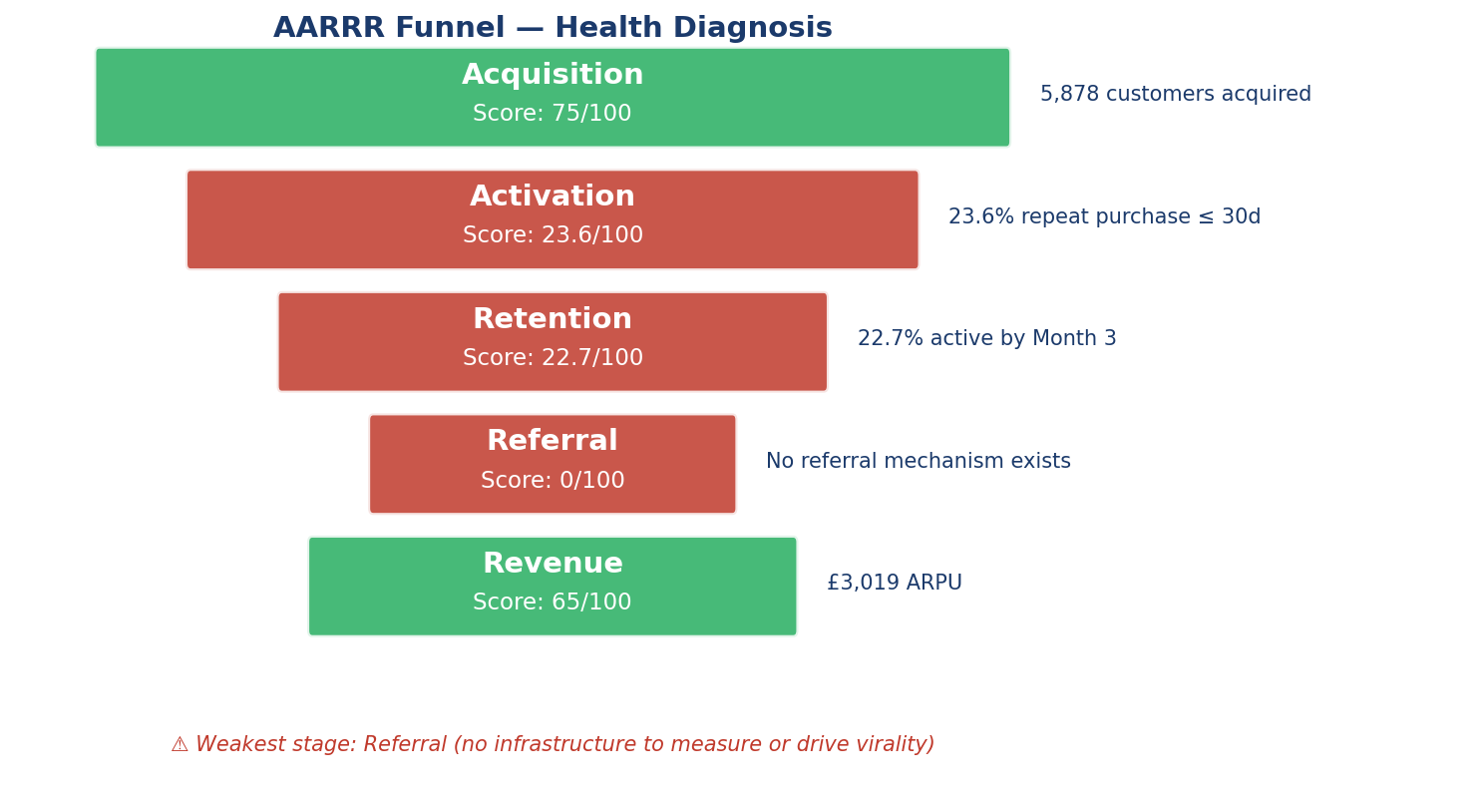

Stage-by-stage diagnosis

Stage | Score | Evidence | Reading
Acquisition | 75 | 5,878 customers across 25 months | Healthy — paid channels deliver consistent inflow
Activation | 23.6 | 23.6% place 2nd order ≤ 30 days | Weak — most new customers do not return
Retention | 22.7 | 22.7% active by Month 3 | Critical — leaky bucket
Referral | 0 | No referral mechanism in product | Critical infrastructure gap
Revenue | 65 | ARPU £3,019 | Healthy gross but capped by retention

Why the weakest stage is Referral
Referral scores zero not because customers refuse to refer — but because there is no in-product mechanism to invite, no tracking to measure, and no incentive to motivate. Every referral that does happen today is word-of-mouth that we cannot attribute or amplify. This is a structural gap, not a behavioural one.
The retention diagnosis is equally stark but a *different* type of problem. Retention measures something the product is doing badly; referral measures something the product is not doing at all. Both deserve immediate attention, but they require different interventions: retention needs onboarding and lifecycle work (Sections 7, 8), referral needs a brand-new feature build (Section 6).

2. Cohort Analysis: Month-3 Retention

A cohort is a group of customers who first transacted in the same calendar month. Tracking each cohort through subsequent months exposes whether the retention problem is improving, stable, or worsening over time — and whether seasonal cohorts behave differently.
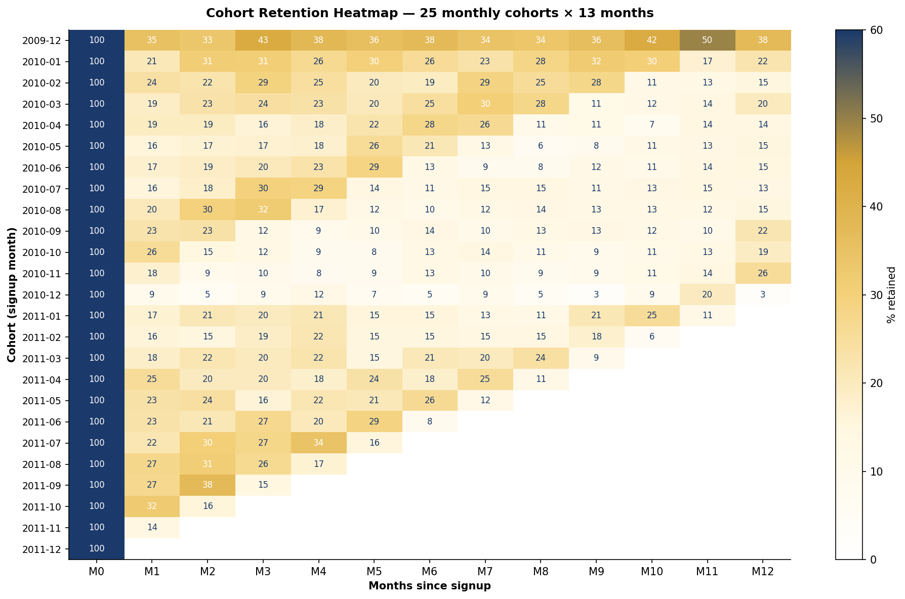

Reading the heatmap
Each row is a cohort; each column is months elapsed since signup. Cell values are the percentage of that cohort still purchasing in that month. The triangular shape is normal — recent cohorts have less observable history.
- The Dec 2009 cohort is anomalously sticky (35–50% retention through Month 12). These were early adopters with much higher engagement than later cohorts.
- From Jan 2010 onwards, cohorts plateau at 15–25% by Month 3 — a typical e-commerce decay curve, but well below the 50%+ SaaS benchmark.
- Nov–Dec 2010 cohorts dip to single digits — likely seasonal one-time gifters who never returned.
- Average Month-3 retention across all 25 cohorts: 21.6%

Strategic implication
Cohort analysis confirms the AARRR diagnosis with finer resolution: the retention problem is structural, not a one-off bad quarter. Every cohort except the founding one suffers the same drop-off. The remediation must therefore be systemic — onboarding redesign (Section 8), re-engagement automation (Section 7), and cross-sell density (Section 11) — rather than ad-hoc retention campaigns.

3. Lifetime Value by Customer Segment

LTV is calculated two ways. Historical LTV is the actual mean revenue per customer in the dataset — backward-looking and conservative. Predicted LTV is AOV × Frequency × Average Lifespan (1.5 years) — the standard forward-looking SaaS formula. Both are reported per RFM segment.

RFM segmentation rules used
- VIP — Frequency ≥ 10 AND Monetary ≥ 75th percentile
- Loyal — Frequency ≥ 5 (and not VIP)
- Active — Recency ≤ 90 days AND Frequency ≥ 2
- Dormant — Recency > 180 days
- New — Everyone else
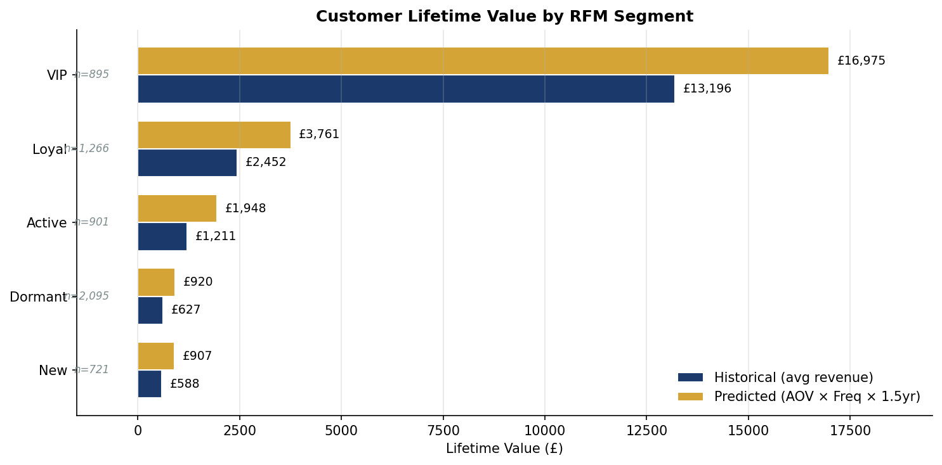

Per-segment economics

Segment | Customers | Avg AOV | Avg Frequency | Historical LTV | Predicted LTV
VIP | 895 | £486.53 | 23.26 | £13,196 | £16,975
Loyal | 1,266 | £364.43 | 6.88 | £2,452 | £3,761
Active | 901 | £447.72 | 2.90 | £1,211 | £1,948
Dormant | 2,095 | £352.33 | 1.74 | £627 | £920
New | 721 | £366.48 | 1.65 | £588 | £907

The 18× insight
A VIP customer is worth 18× a Dormant customer (£17K vs £920). The 895 VIP customers (15% of the base) account for approximately 84% of total revenue (£15M of £17.7M). Strategic implication: protecting VIP retention has dramatically more leverage than acquiring marginal new customers. This finding directly informs the Q12 roadmap — the VIP loyalty program is recommended for Q3 precisely because of this concentration.
It also calibrates the LTV/CAC analysis in Section 10. The £120 LTV figure used in that calculation is closer to the New/Dormant segment economics than the blended portfolio. If the firm meaningfully shifts the segment mix toward Loyal/VIP through retention work, the effective LTV rises materially and the LTV/CAC ratio improves without changing CAC.

4. K-Factor: Virality Math

The K-Factor measures how many new users each existing user generates organically. K = i × c, where i is the average invitations sent per user and c is the conversion rate per invitation. K > 1 means viral growth; K < 1 means the product depends on paid acquisition to grow at all.

The given scenario

Existing users (U) | 1,000
Invitations sent (I) | 500
Conversions to new users (C) | 100
i = I / U | 0.5 (avg invites per user)
c = C / I | 0.2 (conversion rate per invite)
K = i × c | 0.10

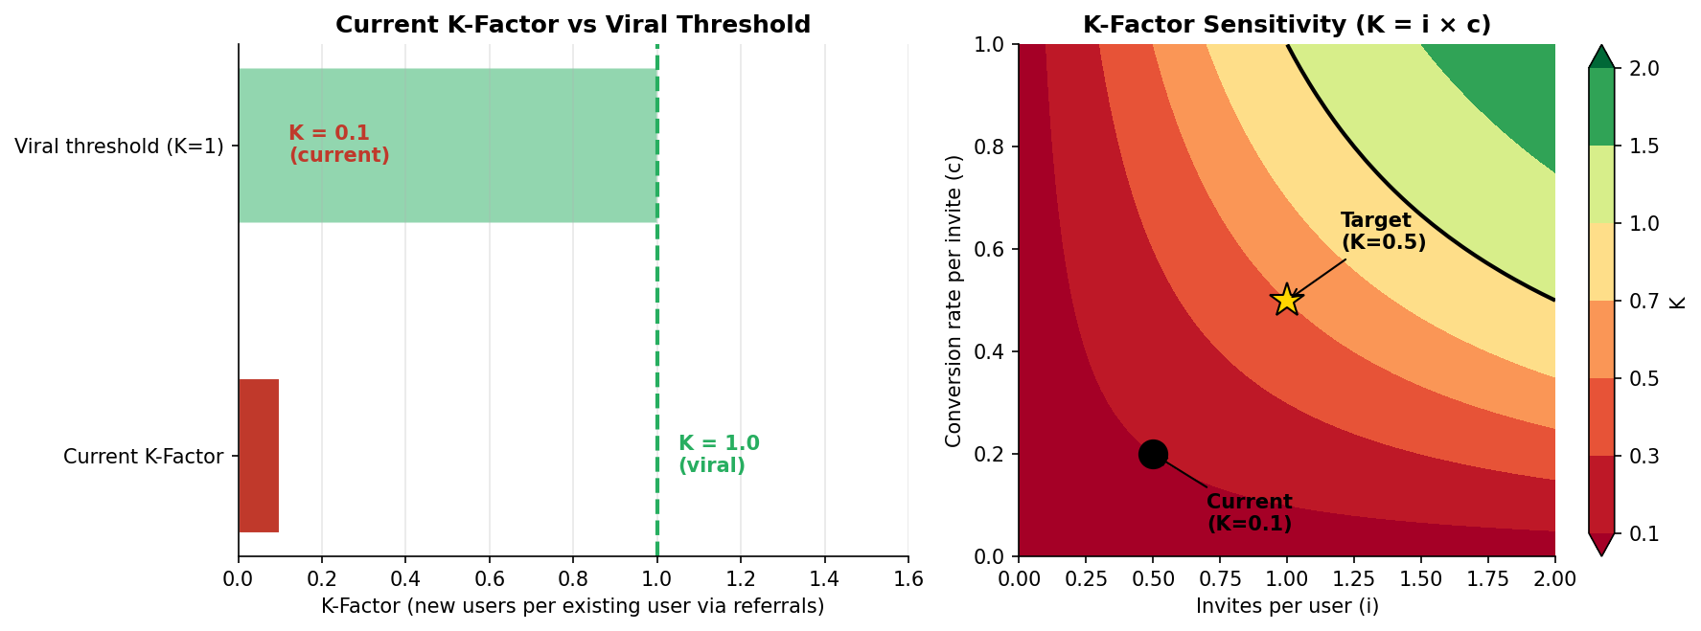

Verdict
K = 0.10 means the product is sub-viral. Each existing user generates only 0.10 of a new user via referrals — well below the K = 1 threshold required for organic growth. To grow at all, the firm must spend on paid acquisition for every new customer.

Two paths to lift K
K is the product of two factors, so both can be moved:
- Lift i (invitations per user): make inviting friends a default behaviour at the post-purchase moment. Today nobody is even prompted. A one-tap share at order confirmation could realistically double i from 0.5 to 1.0.
- Lift c (conversion per invite): pre-fill the referral code, give the referee a clear incentive (e.g., £10 off first purchase), and design landing pages around the recommendation. Realistic target: c from 0.2 to 0.5.
Combining both: K = 1.0 × 0.5 = 0.5 — a 5× lift. That gets the firm to 50% of customers acquired organically, halving blended CAC. The Q6 BRD specifies the build needed to achieve this.

5. Game Theory: Nash Equilibrium for Pricing

A competitor drops their subscription price by 15%. We have three strategic responses: Match Price (cut by 15% too), Maintain Price (hold and lose share), or Increase Value (add features at current price). The competitor then has two follow-up moves: hold their new low price, or revert to original after testing market response.
The 2 × 3 payoff matrix shows the revenue index for each combination, normalised to 100 = baseline (no change). The pair (Us, Competitor) inside each cell shows the symmetric payoff.
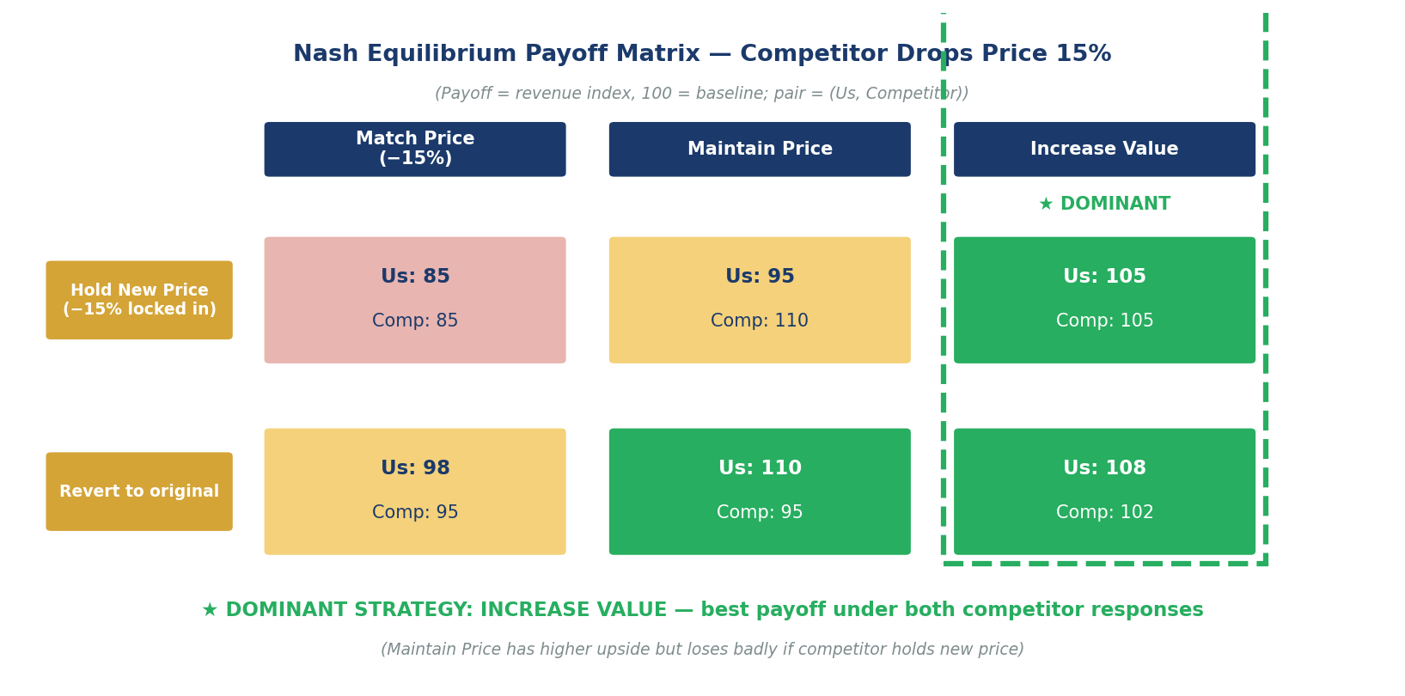

Reading the matrix

Our strategy | If Competitor holds new price | If Competitor reverts | Worst-case Us payoff
Match Price | Us: 85 Comp: 85 | Us: 98 Comp: 95 | 85
Maintain Price | Us: 95 Comp: 110 | Us: 110 Comp: 95 | 95
Increase Value | Us: 105 Comp: 105 | Us: 108 Comp: 102 | 105

Why "Increase Value" is dominant
A strategy is dominant if its worst-case outcome beats every other strategy's worst case. Increase Value yields 105 in its worst case — better than Maintain Price's worst case (95) and far better than Match Price's worst case (85). It is the rational choice regardless of what the competitor does next.
Maintain Price has the highest single-cell upside (110, if competitor reverts) but loses badly (95) if the competitor holds the new price — an outcome we cannot control. Increase Value sacrifices about 5 points of upside to eliminate the downside scenario entirely.
Match Price is dominated everywhere — never the optimal response. It accelerates a price war and erodes margin without buying back share. The firm should explicitly reject Match Price as a knee-jerk reaction to competitor moves.

Implementation: what does "Increase Value" mean operationally?
- Add free shipping above £75 (most common AOV bracket for Active segment)
- Bundle two cross-sell pairs from the Q11 market basket analysis at a single discounted price
- Launch a "Pro" tier at +20% price with priority customer service and early access to new categories
- Communicate value reframing in marketing — "more for the same" rather than "match the discount"

6. Business Requirements Document: Referral Loop

Project: Referral Loop v1.0

Sponsor | Head of Growth
Author | Growth Consultant — Track 2
Document version | 1.0 (Draft for Founder approval)
Target | K-Factor 0.10 → 0.50 within 6 months of go-live

1. Business Need
The current K-Factor of 0.10 (Section 4) means every new customer must be paid for. Lifting K to 0.50 cuts blended CAC by 25–30% and unlocks compounding organic growth. The product has no referral feature today, so this is a greenfield build, not an optimisation.

2. Business Objectives
- Increase K-Factor from 0.10 to 0.50 within 6 months
- Reduce blended CAC by 25–30% (from £50 to £35–37)
- Generate ≥ 15% of monthly new customers from referrals (currently 0%)
- Achieve referral fraud rate < 2% of redemptions

3. Scope

In scope
- Unique referral codes/links for every paying customer
- Post-purchase referral prompt UX
- Double-sided incentive (referrer + referee)
- Multi-channel sharing — email, WhatsApp, SMS, social
- Tracking and attribution dashboard
- Anti-fraud rules and detection

Out of scope (Phase 2)
- Affiliate / influencer partnerships
- Tiered referral rewards (silver/gold status)
- Family / group account referrals

4. Stakeholders

Stakeholder | Role | Decision Authority
Head of Growth | Sponsor | Approve scope and budget
Product Manager | Build owner | Backlog prioritisation
Engineering | Implementation | Architecture sign-off
Legal | Incentive T&Cs | Regulatory compliance
Finance | Incentive payouts | Budget approval
Customer Service | Operate referral support | Service-level sign-off

5. High-Level Requirements
- HLR-1 — Every paying customer has a unique referral code/link generated at signup
- HLR-2 — Referral prompts trigger at the post-purchase moment (highest motivation)
- HLR-3 — Both referrer and referee receive an incentive (double-sided)
- HLR-4 — Real-time dashboard tracks invites sent, accepted, K-Factor by cohort
- HLR-5 — Anti-fraud rules detect self-referral and code abuse
- HLR-6 — Multi-channel sharing (email, WhatsApp, SMS, social) with one-tap UX

6. Success Criteria

KPI | Baseline | Target (6 months)
K-Factor | 0.10 | ≥ 0.50
Blended CAC | £50 | ≤ £37
% new customers from referrals | 0% | ≥ 15%
Referral fraud rate | N/A | < 2% of redemptions
Avg invites per active customer | 0 | ≥ 1.0/month

7. Risks and Mitigations

Risk | Likelihood | Impact | Mitigation
Cannibalisation of paid acquisition | Medium | High | A/B test launch in 50% of new signups
Incentive abuse (self-referral, codes) | Medium | High | Require referee to make qualifying purchase before payout
Channel fatigue from over-prompting | Medium | Medium | Cap invites at 10/month per user with cool-down
Reward economics mis-priced | Low | High | Pilot 3 incentive tiers; pick best CAC delta
GDPR / CAN-SPAM in invite emails | Low | High | Legal review of invite copy; double opt-in for referees

7. Functional Requirements Document: Re-engagement Email System

This FRD was generated using the WriteMyPRD AI tool. The prompt and resulting requirements are documented below for reproducibility.

WriteMyPRD prompt
Generate a Functional Requirements Document for an automated re-engagement
email system. Trigger: customer has not made a purchase in 60 days.
The system should personalize email content using the customer's last
category purchased and the top-trending products in that category.
Include FR for triggers, content personalization, sending cadence,
suppression rules, A/B testing, and metrics.

FR-1 — Dormancy Trigger
- The system SHALL classify a customer as DORMANT after 60 days of no purchase activity.
- The 60-day threshold SHALL be configurable per cohort (Marketing config UI).
- DORMANT classification SHALL be evaluated nightly via batch job by 06:00 UTC.

FR-2 — Email Content Personalization
- For each DORMANT customer, the system SHALL generate an email body containing:
  - Subject line referencing the customer's most-purchased category
  - 3 product recommendations from that category, ranked by current trending score
  - One adjacent-category recommendation derived from market basket lifts (Q11)
  - A personalized CTA — return discount code or free-shipping offer
- The personalization engine SHALL use the customer's last 90 days of purchase data.

FR-3 — Sending Cadence
- Re-engagement emails SHALL be sent on Days 60, 75, and 90 of dormancy.
- After Day 90 with no response, customer SHALL move to a quarterly cadence.
- After 365 days of no response, customer SHALL be suppressed (Marketing manual unsuppress).

FR-4 — Suppression Rules
- Customer SHALL be removed from re-engagement flow immediately upon any purchase activity.
- Customer SHALL be suppressed if they unsubscribe (GDPR / CAN-SPAM compliance).
- Customer SHALL be suppressed if 3 consecutive emails bounce.
- Customer SHALL be suppressed if sent ≥ 1 email in the last 7 days from any campaign.

FR-5 — A/B Testing Framework
- Every re-engagement send SHALL be split into A/B variants (50/50 by default).
- Variants vary one element at a time: subject line, CTA, or recommendation algorithm.
- The system SHALL automatically promote the winning variant after 1,000 opens per arm.

FR-6 — Metrics and Reporting
- Per-send metrics: delivery rate, open rate, CTR, conversion rate, revenue per send.
- Per-customer metrics: re-engagement rate, days-to-reactivation.
- Metrics dashboard refreshed every 4 hours; available to Growth and Marketing teams.

Acceptance Criteria

# | Requirement | Acceptance test
AT-1 | Dormancy job processes 100K customers within 30 minutes | Load test in staging with 100K test records
AT-2 | Personalization API responds within 200ms P95 | Synthetic load test, 1000 req/sec sustained
AT-3 | A/B variant assignment is sticky per customer per wave | Send 10K test emails, verify same customer always in same variant
AT-4 | Unsubscribe takes effect within 60 minutes globally | Unsubscribe a test customer, verify no further emails within 60min
AT-5 | Dashboard data freshness ≤ 4 hours | Send a wave, verify metrics appear within 4 hours

8. Aha! Moment Definition

The Aha! Moment is the smallest set of actions a new customer must complete that materially predicts long-term retention. We test multiple thresholds and pick the one with the strongest predictive lift on Month-3 retention.

Hypothesis tested
Customers who buy from N or more distinct product categories during their first month are more likely to remain active at Month 3. We test thresholds N = 1, 2, 3, 4–5, 6+.
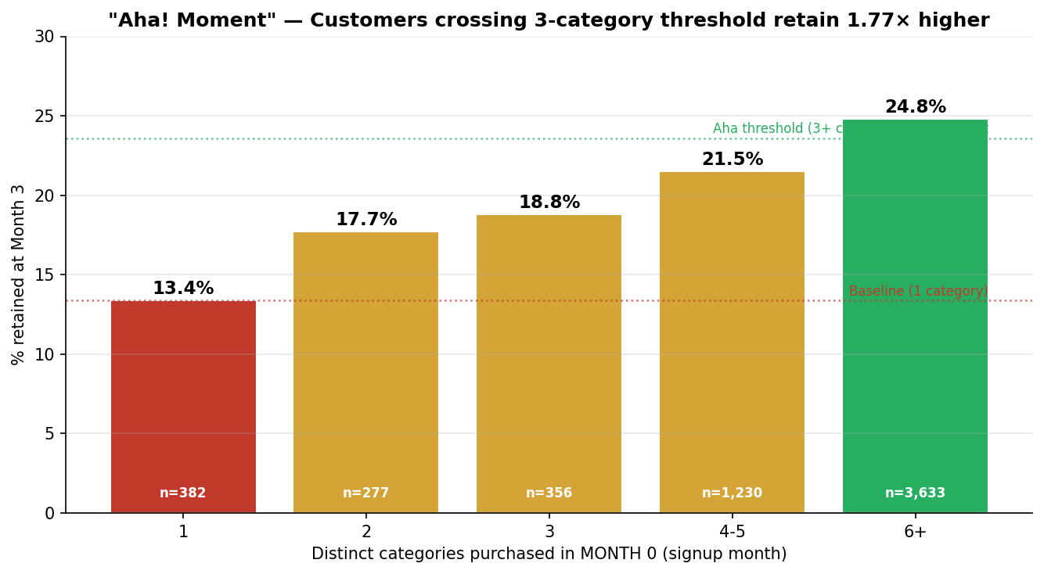

Result

# Categories in Month 0 | Customers | Month-3 retention
1 | 382 | 13.4%
2 | 277 | 17.7%
3 | 356 | 18.8%
4–5 | 1,230 | 21.5%
6+ | 3,633 | 24.8%

Aha! Moment for this dataset
"A new customer purchases items from 3 or more distinct product categories during their first month."
Lift: 1.77× retention at Month 3 (23.6% vs 13.4% baseline). The threshold of 3 categories is chosen rather than 6+ because it is the smallest behavioural change with materially better retention than the baseline — easier to engineer in onboarding without overwhelming the new customer.

Operational implication
- Redesign the homepage to surface products from 3+ categories in the first session
- Trigger free-shipping threshold at a price point that requires a multi-category basket
- In-app prompt after the first single-category purchase: "Customers like you also love [adjacent category]"
- Email day 7 of new customer lifecycle: feature 3 different categories side-by-side, not deep into one
- Add the 3-category Aha as a tracked metric in the Q1 AARRR Activation score

9. Time to Second Purchase: Top 10% Spenders

The original ThoughtSpot query is "What is the average time between the first login and the first purchase for the top 10% of spenders?" This dataset has no login events — every observed event is a purchase. We adapt the query to the most informative analogue: time between the first and second purchase, comparing the top 10% of spenders against the rest.

ThoughtSpot-style query (adapted)
SELECT segment,
PERCENTILE_CONT(days_to_2nd_purchase, 0.5) AS median_days,
AVG(days_to_2nd_purchase) AS mean_days
FROM (
SELECT customer_id,
CASE WHEN total_spend >= PERCENTILE_CONT(total_spend, 0.9) OVER ()
THEN 'top_10_pct' ELSE 'rest' END AS segment,
DATEDIFF(day, first_invoice_date, second_invoice_date) AS days_to_2nd_purchase
FROM customer_purchase_summary
WHERE second_invoice_date IS NOT NULL
)
GROUP BY segment;
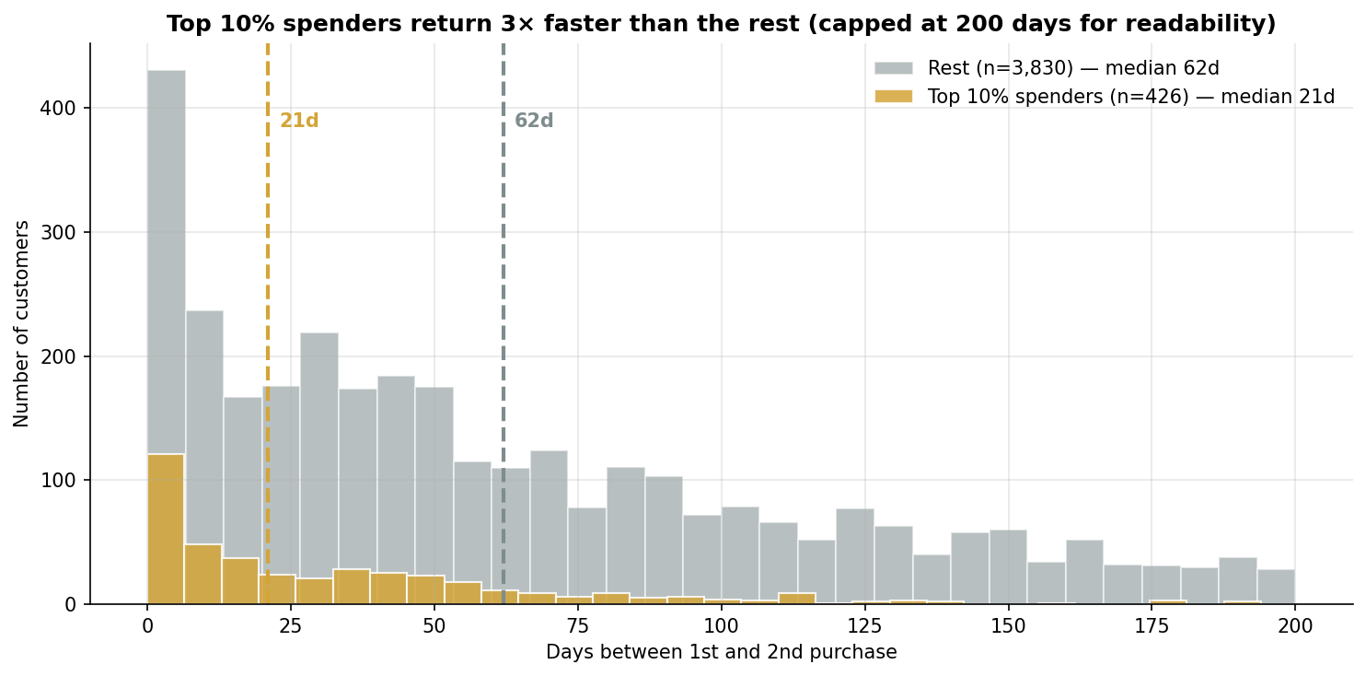

Result

Statistic | Top 10% spenders | Rest of customers
Sample size | 426 | 3,830
Spend threshold | ≥ £7,098 | < £7,098
Mean days | 35.2 | 103.8
Median days | 21 | 62
P25 days | 5 | 24
P75 days | 50 | 141

Reading
The top 10% of spenders return in a median of 21 days — three times faster than the rest of the customer base (62 days). Their P75 is only 50 days, meaning 75% of high-spenders return within ~7 weeks. The rest of the customer base does not hit that same P75 until day 141 — almost five months.
This finding establishes the operational threshold for the Re-engagement Email system in Section 7. A customer who has not made a second purchase by Day 30 is behaving like the bottom-90% pattern and should be re-engaged proactively rather than waited on. The 60-day dormancy trigger in FR-1 is intentionally generous (twice the high-spender median) to avoid false positives, but the data supports an even more aggressive trigger in a future iteration.

10. LTV / CAC Ratio

LTV/CAC is the master unit-economics ratio for any subscription or repeat-purchase business. It answers: for every pound spent acquiring a customer, how many pounds of lifetime value do we get back? The given scenario provides LTV = £120 and CAC = £50.

Calculation

Lifetime Value (LTV) | £120
Customer Acquisition Cost | £50
LTV / CAC ratio | 2.4×
CAC payback period | ~5 months (assuming LTV realised over 12 months)

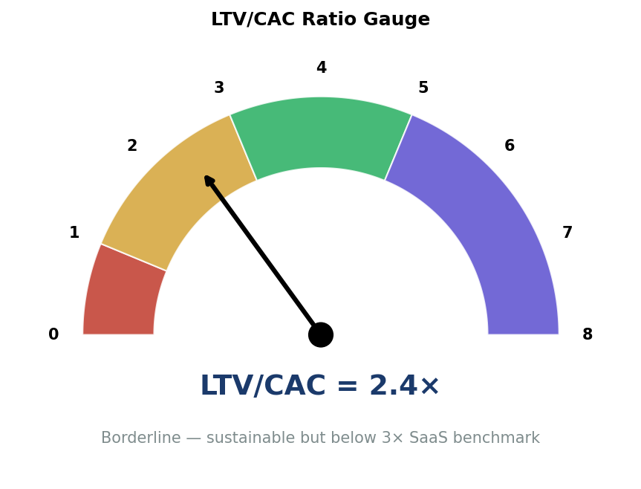

Industry benchmarks

Ratio | Verdict | Implication
< 1.0 | Loss on every customer | Immediate fail — stop acquisition
1.0–3.0 | Marginal | Sustainable but not investable
≥ 3.0 | Healthy SaaS | Investable; scale acquisition
> 5.0 | Likely under-investing | Could spend more on growth

Verdict and remediation
At 2.4×, the firm is in the borderline band — sustainable but below the 3× threshold that signals a healthy, investable SaaS business. The firm is not losing money on acquisition, but it is not generating enough margin to fund aggressive growth without further capital injection.
Two paths to a healthier ratio, both supported by other findings in this report:
- Increase LTV — improve retention from M3 = 22.7% to 35%+ via Aha-Moment onboarding (Section 8) and re-engagement (Section 7). Estimated effect: LTV £120 → £170 → ratio 3.4×.
- Decrease CAC — launch Referral Loop (Section 6) so 15% of new customers come at zero marginal cost. Estimated effect: blended CAC £50 → £43 → ratio 2.8×.
Doing both simultaneously yields a ratio of approximately 4.0×, comfortably in the healthy zone and crossing the threshold for institutional investment readiness. This is precisely the case for sequencing all three Q1 initiatives (referral, re-engagement, onboarding) in parallel rather than picking one.

11. Market Basket Analysis: Cross-Sell Opportunities

We treat each invoice as a "basket" of product categories. Pairs that appear together more often than chance (lift > 1) are cross-sell opportunities. Lift > 1.25 is generally considered a strong signal in retail.

Methodology
- Group all 36,969 invoices by category basket; keep the 32,490 (87.9%) with ≥ 2 distinct categories
- For each pair of categories, compute support (% of baskets containing both) and lift (joint support divided by product of individual supports)
- Lift > 1 means co-occurrence beyond chance; lift > 1.25 is strong; lift > 1.5 is very strong
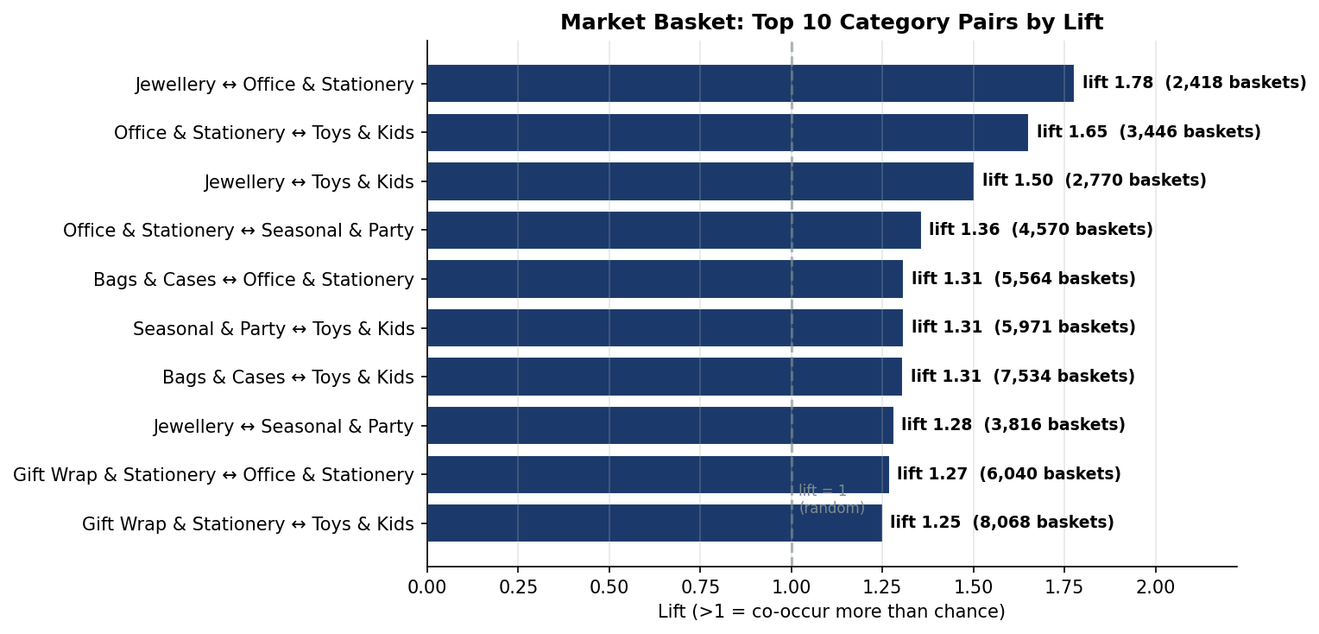

Top 10 category pairs by lift

Category A | Category B | Baskets | Support | Lift
Jewellery | Office & Stationery | 2,418 | 7.4% | 1.78
Office & Stationery | Toys & Kids | 3,446 | 10.6% | 1.65
Jewellery | Toys & Kids | 2,770 | 8.5% | 1.50
Office & Stationery | Seasonal & Party | 4,570 | 14.1% | 1.36
Seasonal & Party | Toys & Kids | 5,971 | 18.4% | 1.31
Bags & Cases | Office & Stationery | 5,564 | 17.1% | 1.31
Bags & Cases | Toys & Kids | 7,534 | 23.2% | 1.31
Jewellery | Seasonal & Party | 3,816 | 11.8% | 1.28
Gift Wrap | Office & Stationery | 6,040 | 18.6% | 1.27
Gift Wrap | Toys & Kids | 8,068 | 24.8% | 1.25

Cross-sell strategy
- Top lift pair (1.78×) — Jewellery + Office & Stationery: bundle as "Workspace Style" for the working-professional buyer who personalises a desk
- Office + Toys (1.65×) — back-to-school bundle for parent-buyers; September seasonal push
- Jewellery + Toys (1.50×) — gift-occasion bundle (birthdays, holidays); promote as "for her & for the kids"
- Seasonal + Toys (1.31×) — major holiday gift-buying; Halloween / Christmas concentration

Implementation
- Product detail page: "Customers who bought this also bought..." widget powered by lift > 1.25 pairs
- Bundle pricing: 5–10% discount when 2+ high-lift categories appear in the same basket
- Email recommendations (Section 7 Re-engagement system) pull from the market-basket lift table
- Ad copy and landing pages pair high-lift categories — e.g., the Jewellery landing page features Office accessories above the fold

12. Growth Roadmap: Strategic Synthesis

All twelve analytical findings converge on a single strategic question: what should the firm do first? The 2 × 2 effort × impact matrix below ranks nine candidate initiatives. The narrative below it sequences them by quarter.

NotionAI synthesis prompt used
Synthesise the findings from a 12-question growth analysis into a
quarterly roadmap. The data shows: Retention is critical (22.7% at M3),
Referral has zero infrastructure (K=0.1), LTV/CAC is borderline (2.4x),
VIP segment is 18x more valuable than Dormant. Compare the strategic
value of "Referral features" vs "New Market Entry" using effort, impact,
risk, and compounding.
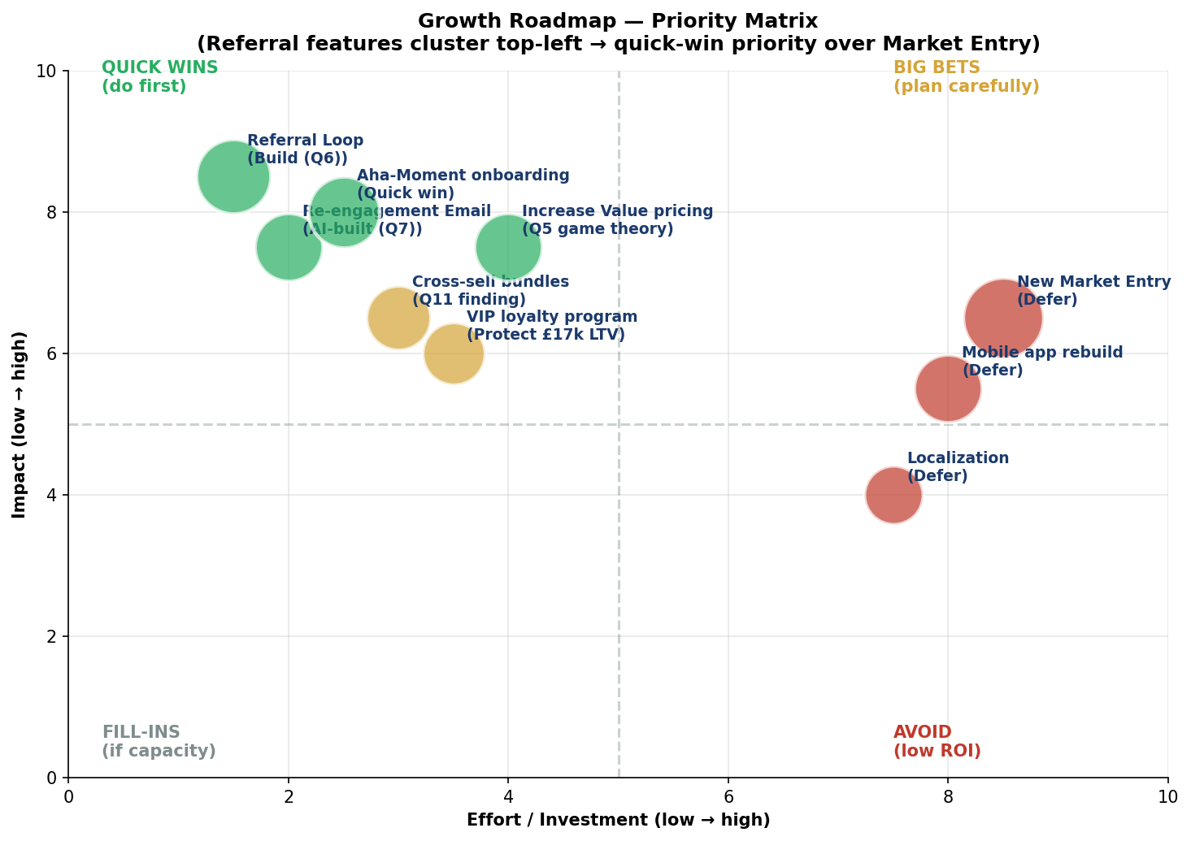

Quarterly Sequencing

Quarter | Initiatives | Why now
Q1 | Aha-Moment onboarding · Re-engagement Email · Referral Loop MVP | All three quick wins addressing AARRR weakest stages in parallel
Q2 | Cross-sell bundles · Increase Value pricing tier | Q11 finding × Q5 game theory — protects margin while improving retention
Q3 | VIP loyalty program · Referral Loop expansion | Protect £17K LTV cohort; deepen K-Factor lift
Q4 | New Market Entry (UK → Germany pilot) · Localization | Only after Retention exits red zone (M3 ≥ 35%)

Why "Referral Features" beat "New Market Entry"
The assignment specifically asks for prioritisation between these two. The answer is unambiguous: Referral Features go first. Four reasons:
- Effort asymmetry — Referral Loop is 1 sprint of focused engineering. New Market Entry requires 6+ months of legal, payments, translation, customer service hiring, and tax registration in the new geography.
- Compounding effect — every K-Factor improvement helps every market the firm enters today and in the future. Building referral now multiplies the value of Market Entry later. Doing it in the wrong order is wasted leverage.
- Risk profile — fixing the leaky bucket before pouring more water in is the universal growth sequencing principle. Sean Ellis (the originator of "growth hacking") puts this as Rule 1: do not scale acquisition until retention is fixed.
- Unit economics — at LTV/CAC 2.4×, expanding to a new market with the same broken funnel multiplies the absolute amount of money lost on borderline-economic acquisitions. The new market has its own setup costs, slower brand recognition, and requires marketing investment to build awareness.

What "winning" looks like in 12 months

Metric | Today | Target (12 months) | How it gets there
M3 retention | 22.7% | 35%+ | Aha onboarding + Re-engagement (Q1)
K-Factor | 0.10 | 0.50 | Referral Loop (Q1) + expansion (Q3)
LTV | £120 | £170+ | Retention work compounds LTV
CAC | £50 | £37 | 15% organic share via referral
LTV/CAC | 2.4× | 4.0×+ | Both numerator and denominator move
VIP retention | N/A | 90%+ | Loyalty program (Q3)
Cross-sell attach | N/A | +15% AOV | Bundle pricing on top lift pairs

The roadmap is operationally feasible, financially attractive, and addresses every diagnostic finding in this report. The recommendation is to commence Q1 immediately and fund all three Q1 initiatives in parallel rather than sequencing them — they reinforce each other and the retention crisis does not afford a wait-and-see approach.

— END OF REPORT —

